**The Role of Risk Coverage, Liquidity and Uncertainty in the Profitability of Commercial Mexican Banks**



**Entrega de Medio Termino**

Alumno: Hebert Santillán Herrera

Asesora: Ana Margarita Alvarado Pacheco

Seminario de Investigación en Economía II

Profesor: Jacques Lartigue Mendoza

Facultad de Economía y Negocios

NRC: 10949

Fecha de entrega: 2 de octubre del 2025

**The Role of Risk Coverage, Liquidity and Uncertainty in the Profitability of Commercial Mexican Banks**

**Abstract**

This paper investigates the impact of bank-specific, macroeconomic variables, and economic policy uncertainty (EPU) on bank profitability in Mexico. The analysis is based on empirical data from the ten largest Mexican commercial banks from 2011 to 2024. We conclude that EPU does not exert a statistically significant influence on bank profitability, whereas operational efficiency, capital risk coverage, and liquidity are found to be important bank-specific factors that significantly affect bank performance.

**Keywords**: Bank profitability, Mexico, economic policy uncertainty, liquidity, risk coverage

**Introduction**

Over the past decades, the profitability among Mexican commercial banks has generally tandem with prevailing economic conditions. This is particularly evident in the most recent economic shock (Alcaraz et al., 2024), with deteriorated credit conditions and the reduction in credit supply. As illustrated in Figure 1, a consistent overall common trend can be observed across institutions where, profitability is represented as the average return over equity (ROE), experiencing a brief decline corresponding to the recent episode of economic contraction and expansion, along with the associated decrease and subsequent increase in interest rates.

The extensive global literature on the determinants of bank profitability has shown that returns are influenced not only by macroeconomic factors but also by strategic decisions taken by individual institutions, which may reduce the impact of external factors. Heterogeneous characteristics among banks, such as their resilience to economic shocks, their liquidity, operational efficiency, and the quality of assets play a significant role in shaping profitability, and can help cushion the impact of adverse external shocks.

This interplay between internal and external factors are particularly relevant during economic shocks. In Mexico, the initial phase of the pandemic was marked by heightened uncertainty and strict lockdown measures (Alcaraz et al., 2024). Uncertainty has gained increasing attention as a determinant of financial indicators, giving that it influences decision-making and risk-taking behavior. While the body of international research on the determinants of bank profitability is extensive, highlighting the role of bank-specific characteristics (Adelopo et al., 2021; Al-Homaidi et al., 2018; Chaudron, 2018; Elekdag et al., 2020), the study of the role of economic policy uncertainty (EPU) is comparatively recent and less explored. However, evidence from other economies suggest that EPU may affect banks by reducing loan sizes, deteriorating asset quality and raising credit risk (Chi & Li, 2017; Orden-Cruz et al., 2023), and ultimately reducing bank profitability (Nasim et al., 2025; Wu et al., 2020). These findings highlight the importance of how-bank specific strengths can mitigate the negative effect of economic uncertainty, particularly during downturns.

**Figure 1: Average Return on Equity, Ten Largest Mexican Commercial Banks**

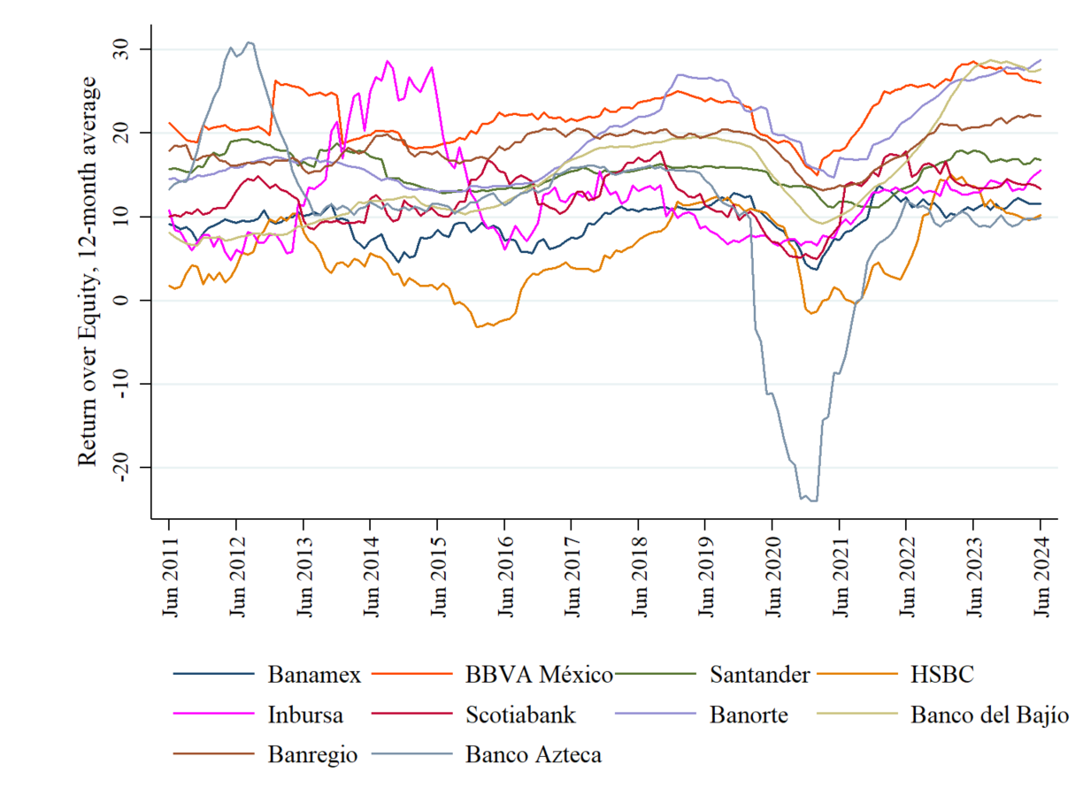

Data shows the 12-month average of Return on Equity from Banamex, BBVA México, Santander, HSBC, Inbursa, Scotiabank, Banorte, Banco del Bajío, Banregio, and Banco Azteca, from June 2011 to June 2024. Own elaboration with data from CNBV.

Despite this, to our knowledge, no prior study has examined the impact of EPU on bank profitability in Mexico. This paper will try to fill in literature gap. Our objective of this article is to identify the key factors that influence profitability indicators in the Mexican banking system. Our study contributes in literature of the determinants of bank profitability by incorporating macroeconomic, bank specific and uncertainty into our model, covering the recent economic shocks such as the pandemic, and analyzing the importance of uncertainty in estimating bank performance.

This analysis is relevant as it offers insightful information into bank operations, helping banks’ managers identify the factors that influence and strengthen overall returns. By highlighting the significant variables, decisionmakers can prioritize their focus on strategies and allocate resources more efficiently, thereby enhancing efficiency and overall profitability. These findings are also of interest to regulators, as it may provide insights into the health and resilience of the banking system to both bank-specific, sector wide shocks and economic outlook of policy. We aim to identify how the banking system reacts to economic policy and the uncertainty surrounding it.

We first estimate following the methodology of

1. **Literature review**

Over the last three decades. There has been a growing body of research examining the determinants of profitability Mexican commercial banks, providing evidence on key contributing factors.

In relation to market power theories, Chortareas et al. (2009) found that, for commercial banks operating between 1997 and 2004, efficiency and capital ratios played an important role in the pursue of profits. Guerrero-Mora & Villalpando-Benítez (2009) suggested that, based on a similar sample, market concentration and financial resilience positively influence profitability.

Additionally, asset quality has been a recurrent topic of interest. Chavarín-Rodríguez (2015) aimed to capture the effect of morosity on profitability after global financial crisis in 2008, but could not find significant relationship. Morales Castro & Espinosa Jiménez (2024), who found that morosity and the size of non-performing loans to negatively affected profitability prior to the pandemic, but reported no significant effects in the post-pandemic period. However, Martínez-Vázquez et al. (2025) had recently found bank profitability to be negative affected by morosity of consumer loans when using an extended period of data and correlation estimation methods, suggesting that morosity may indeed play a more significant role than previously assumed.

Risk coverage factors have likewise emerged as areas of inquiry in the study of bank profitability in Mexico, as banks with higher liquidity and capitalization exhibit greater resilience to economic shocks (Chiguil-Rojas et al., 2024). Capital ratios have been associated to increments in profitability, as a consequence of banks expecting greater profitability and transmitting such information to the public via increases in capital, as well as higher incentives for shareholders to monitor management and efficiency (Chavarín, 2014; Chortareas et al., 2009; Guerrero & Villalpando, 2009).

Theoretical models generally showcase how both internal factors and the overall economic environment impact profitability (Ozili, 2017). Following standard practices, we formulate our hypotheses on the interactions between macroeconomic, and bank-specific variables based on the reviewed literature.

1. **Economic growth and bank profitability**

Economic growth is commonly used in literature as a control variable, as it provides a comprehensive insight into the influence business cycles in profitability (Bikker & Vervliet, 2018). Bank profitability has been found to be procyclical, with a greater Gross Domestic Product (GDP) improving the financial conditions for borrowers, which enhances credit portfolio quality and lending activity (Albertazzi & Gambacorta, 2009). Empirical evidence indicates that GDP growth positively influences banks profitability, as shown by Al-Homaidi et al. (2018) for commercial Indian banks, and Adelopo et al. (2021); Elekdag et al. (2020) for the largest banks in the European Union, among others.

In Mexico, economic activity has been found to increase credit supply (Chiguil-Rojas et al., 2024), which in turn may increase profitability, as credit supply shocks positively correlate profitability Alcaraz et al. (2024). However, Chavarín-Rodríguez (2015), and Morales Castro & Espinosa Jiménez (2024) did not find statistically significant results confirming that economic activity is associated to bank profitability, although the relationship was positive. Using a different measure to identify economic growth tendencies, we anticipate a positive association.

1. **Inflation and bank profitability**

Inflation also provides valuable insights into the broader economic environment, although literature offers mixed evidence on its effect on bank profitability. Several articles have found evidence of a positive relationship (Bikker & Vervliet, 2018), while other identify a negative relationship (Ayaydin & Karakaya, 2014; Sajid Saeed, 2014) between inflation and profitability. Adelopo et al. (2021) highlights that the accurate prediction of change in inflation rates is crucial, as banks modify their interest rates based on their predictions the rate. While higher inflation boosts expectation of bank profitability through larger net interest margins (Converse & Jain, 2024), a negative relationship may arise from the slow adjustment of interest rates relative to inflation rate, which may increase bank costs faster than revenues (Ayaydin & Karakaya, 2014). In Mexico, evidence is mixed and inconclusive.

1. **Interest rates and bank profitability**

A general consensus in literature has suggested a positive effect of increases in interest rates to commercial bank profitability. Early work by Samuelson (1945) proposed that the individual banks benefit from increases in interest rate under general conditions, mainly profits are more sensitive to loan rates than deposit rates, which was empirically evaluated by Hancock (1985) for commercial banks in the United States.

Since, other articles have concurred with these findings. Bikker & Vervliet (2018) found that in the commercial and saving banks in the United States from 2001 to 2015, falling interest rates impairs bank performance as net interest margins compress. In Mexico, Morales Castro & Espinosa Jiménez (2024) had previously found a 1% increase in interest rate increased ROE by 2.3 units in a mix of 31 banks between 2011 and 2019. For these reasons, we expect short term interest rates also to positively affect profitability studied in this article.

1. **Operational efficiency and bank profitability**

Efficiency of asset management has been shown to contribute to bank performance, as the reduction of costs improve productivity (Al-Homaidi et al., 2018).

Chortareas et al. (2009) had previously found supportive evidence of the Efficient Structure (ES) hypothesis in the Mexican banking system from 1997 to 2004, using alternative measures of profitability such as interest rate spreads and return over assets. The ES hypothesis posits that efficiency plays a crucial role in determining profitability and, ultimately contribute to growth. Additional evidence from Chavarín-Rodríguez (2015) substantiate this view.

1. **Capital risk coverage and bank profitability**

Capital risk coverage reflects the institution’s resilience when absorbing potential losses. Traditional literature suggests that at higher capitalization ratio, banks reflect risk-aversion, and profitability diminishes as a result of low levels of resources to lend. Papers that substantiate this view include Ayaydin & Karakaya (2014). Additionally, Chiguil-Rojas et al. (2024) recently documented a negative relationship between capital levels and credit supply, support this idea.

However, a positive relationship between capitalization and profitability may also signal favorable demand conditions for loans, which may also boost profits, as found by Molyneux et al. (1998) for US commercial banks from 1987 to 1991, and the aforementioned study by Adelopo et al. (2021). Chortareas et al. (2009), Chavarín (2014) who provide supporting evidence for Mexican commercial banks, and for this reason we expect similar results.

1. **Liquidity and bank profitability**

Liquidity is defined as the capacity of banks to meet their short-term financial obligations. Common bank profitability literature suggests that liquidity and bank profitability have an inverse relationship. Jokipii & Milne (2011) explains that banks higher levels of liquidity are less constrained by minimum capital requirements and are more willing to increase their level of risk. Empirical evidence worldwide includes Nepalese commercial banks over the period 2005 to 2013 (Pradhan & Shrestha, 2017), and Turkish commercial banks from 2003 to 2011 (Ayaydin & Karakaya, 2014).

Contrary to conventional bank profitability literature, Mashamba (2018) found that liquidity positively affect bank profitability in banks operating in emerging countries. One explanation of such deviation is that some banks from inefficient emerging markets may prefer to invest to keep a conservative portfolio of liquid, low-risk government bonds, as supposed to lending to the private sector (Chiguil-Rojas et al., 2024).

1. **Asset quality and bank profitability**

Asset quality, that is the risk of nonperformance of loans having a significant portion of total credit portafolio. Chavarín-Rodríguez (2015) previously found morosity not to be a significant determinant driving profitability for Mexican commercial banks when using a period of data between 2007 to 2013. However, a recent study by Martínez-Vázquez et al. (2025), which examined an extended period from 2011 to 2023 and employed correlation analysis via Copulas, identified a negative correlation, which may indicate that asset quality does in fact affect profitability.

1. **Diversification and bank profitability**

Specialization refers to the extent in which interest income from the issuance of credit dominate total operational income relative to other sources of income, such as fees and commissions. Chavarín-Rodríguez (2015) had previously found non-interest revenue to contribute to overall profitability, although coefficients were small.

1. **Economic policy uncertainty and bank profitability**

The inclusion of economic policy uncertainty EPU in bank profitability literature is recent and relatively scares. Nevertheless, existing evidence suggests that credit supply and asset quality are affected. Evidence suggests that economic policy uncertainty negatively affect lending decisions by increasing banks’ credit risks and reducing loan size, as found by Chi & Li (2017) for Chinese commercial banks from 2007 to 2014, and Orden-Cruz et al. (2023) for US commercial banks from 2017-2019. Wu et al. (2020) found evidence suggesting EPU to increase bank risk and decreasing profitability in emerging economies. Athari & Bahreini (2023) found similar results for Islamic banks from 2003 to 2017. Recently, Nasim et al. (2025) analyzed the 109 largest banks from G7 and E7 economies, and found EPU to have strong adverse effect on profitability.

Studies of EPU in Mexico are recent and focus on its effect on real and financial markets. Evidence shows that EPU significantly negatively impact on stocks (Sosa Castro et al., 2022), and produce higher exchange rate volatility (Bush & López Noria, 2021) in Mexico, suggesting that high liquidity financial markets quickly incorporate economic news. Accordingly, bank profitability is also expected to be negatively affected by uncertainty.

1. **Data**

The data used for this article comprise a balanced panel from the ten largest commercial banks operating in Mexico, which include Banamex, BBVA México, Santander, HSBC, Inbursa, Scotiabank, Banorte, Banco del Bajío, Banregio, and Banco Azteca. As of June 2024, these banks captured 88.069% of total earnings and 81.122% of assets in the Mexican Banking system, therefore reflecting their overall dominance in the sector. Data is evaluated from June 2011 to June 2024, compiled in a monthly frequency. In total there were 1570 observations.

In line with bank profitability literature, we use the average return over equity (ROE) as our dependent variable, calculated as the total net income accumulated over 12 months divided by average equity over 12 months. ROE reflects how efficiently banks generate returns to their shareholders.

**Table 1. Descriptive Statistics of Variables, All Banks**

|  |  |  |  |  |  |  |
| --- | --- | --- | --- | --- | --- | --- |
|  |  | .Obs | Mean | Std. Dev. | Min. | Max. |
| Endogenous variable: | |  |  |  |  |  |
|  | ROE | 1570 | 13.986 | 6.877 | -23.953 | 30.822 |
| Macroeconomic controls: | |  |  |  |  |  |
|  | GROWTH | 1570 | 1.709 | 2.981 | -8.992 | 6.628 |
|  | INF | 1570 | 4.503 | 1.541 | 2.130 | 8.700 |
|  | INT | 1570 | 5.866 | 2.569 | 2.670 | 11.320 |
| Uncertainty variable: | |  |  |  |  |  |
|  | EPU | 1570 | 61.714 | 29.635 | 12.090 | 161.470 |
| Bank-specific characteristics: | |  |  |  |  |  |
|  | AM | 1570 | 1.073 | 0.865 | -3.616 | 5.816 |
|  | CAR | 1570 | 15.905 | 2.608 | 11.520 | 26.380 |
|  | LIQ | 1570 | 16.353 | 7.789 | 2.438 | 47.499 |
|  | MOR | 1570 | 4.896 | 2.877 | 1.190 | 22.551 |
|  | NIR | 1570 | 30.016 | 64.907 | -38.988 | 2,426.957 |

Data is comprised from observations of all banks (Banamex, BBVA México, Santander, HSBC, Inbursa, Scotiabank, Banorte, Banco del Bajío, Banregio, and Banco Azteca), the Economic Policy Uncertainty Index, and macroeconomic variables from June 2011 to June 2024. Own elaboration with data from CNBV, Banxico, INEGI, and the Economic Policy Uncertainty Index developed byBaker et al. (2016).

Bank-specific indicators related to their financial situation, resilience, and efficiency we employ in the model include the following variables:

* Operational efficiency (AM), calculated as the percentage of the operating profit divided by total assets.
* Capital adequacy ratio (CAR), measured as the bank’s capital relative to their risk-weighted assets.
* Liquidity (LIQ), measured as the ratio between total liquid assets and total assets.
* Morosity (MOR), calculated as Adjusted Deliquency Index, defined as the ratio of loans at Stage 3[1] plus accumulated write-offs and debt forgiveness, to total credit portafolio at risk, including the aforementioned write-offs and debt forgiveness.
* Diversification (NIR), calculated as the ratio of commissions, fees and other non-interest rate incomes, to total operative income.

Under the Credit Institutions Law, commercial banks are required to periodically publish their financial and operational information, which is made publicly available by the Comisión Nacional Bancaria y de Valores (CNBV) via their information portal. In Mexico, the CNBV acts as the regulatory body responsible for supervising and regulating financial institutions. In this article, we utilize this statistical data to construct the profitability indicator (ROE), as well as bank-specific characteristics (AM, LIQ, MOR, NIR). Data for CAR is calculated and made publicly available by Bank of Mexico (Banxico). We opt to use this capital ratio as to provide a comprehensive assessment of a bank’s financial strength, as using the commonly used leverage ratio does not account for the market risk of assets.

Additionally, following Nasim et al. (2025), we account for economic policy uncertainty using the Economic Policy Uncertainty index for Mexico, estimated using the methodology developed by Baker et al. (2016).

* Economic Policy Uncertainty (EPU), which reflets the scaled monthly count of articles containing terms related to economics, policy, and uncertainty.

The EPU index is estimated using digital text archives of locally newspapers coverage. Data is normalized to a mean of 100. For a detailed description on the methodology employed in its calculation, see Economic Policy Uncertainty (2012). Figure 2 presents the EPU index for Mexico compared to the ROE of individual banks and the mean value of all banks. The graph suggests that EPU is volatile with the peak experience in 2016 coinciding with US elections and concerns about NAFTA, and the peak in early 2020 coinciding with the pandemic and lockdown policy.

**Figure 2. Economic Policy Uncertainty Index for Mexico and ROE from all banks**

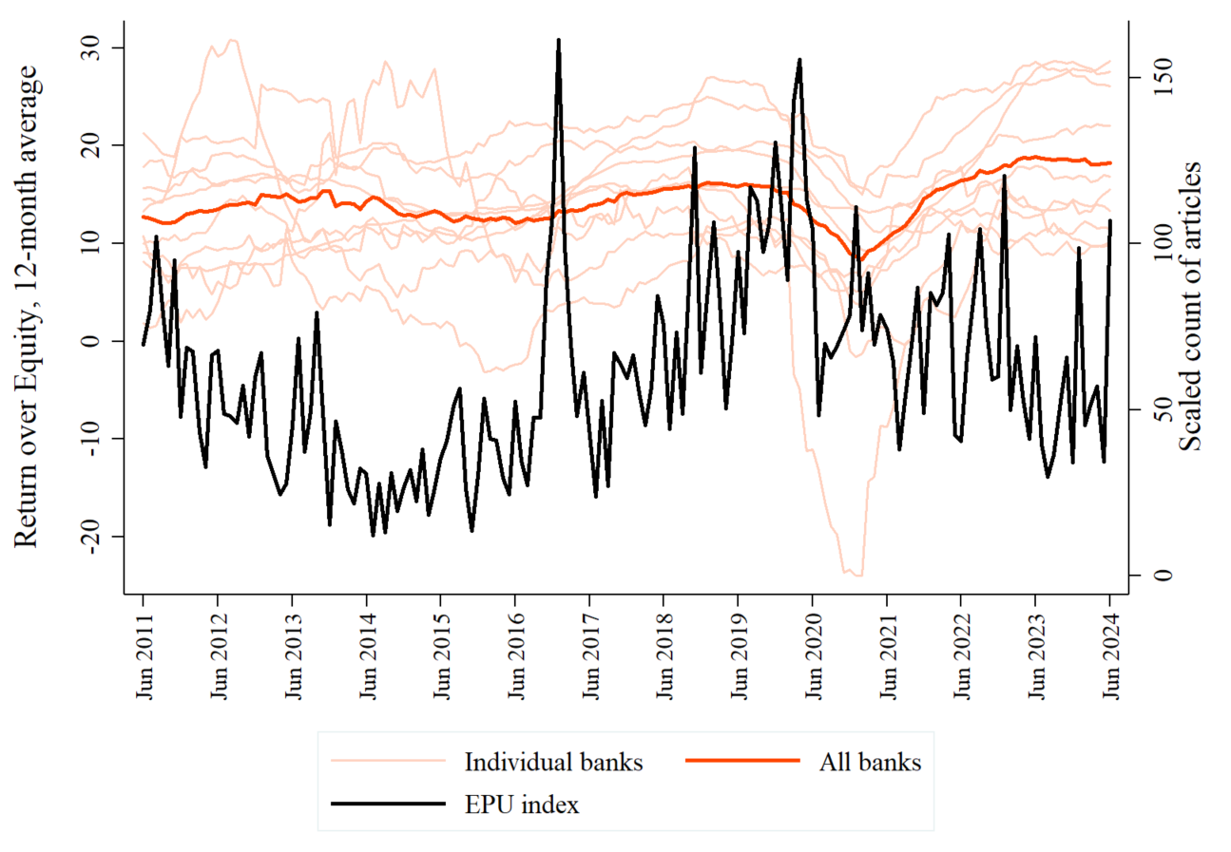

Figure shows the 12-month average of Return on Equity from individual banks, and the mean from all banks of sample, compared to the Economic Policy Uncertainty Index from June 2011 to June 2024. Own elaboration with data from CNBV and the Economic Policy Uncertainty Index developed byBaker et al. (2016).

Following common literature practices, we also make use of control variables to account for macroeconomic conditions and other factor that may influence the results. We include the following variables:

* Economic growth trend (GROWTH), which is calculated with the 12-month average of log differences of year-by-year of preliminary GDP figures, which captures the underlying trend of the growth rate.
* Inflation rate (INF), which is calculated with the log differences of year-by-year Consumer Price Index.
* Short term interest rate (INT), which captures monetary policy.

The data we use to account for macroeconomic indicators include the Global Index of Economic Activity (IGAE) which provides a monthly measure of GDP, and the Consumer Price Index (CPI) which measure the variation of prices of a basket of goods and services representative of household consumption in Mexico. To account for large fluctuations derived from economic shocks and capture the gradual effect on bank profitability, we apply a moving average. This approach smooths short-term volatility and highlights the underlying trend. Figure 3 presents a comparison between year-on-year GDP growth and moving average. Individual banks and their mean ROE follow closely the trend of economic growth.

**Figure 3. Economic growth trend and ROE from all banks**

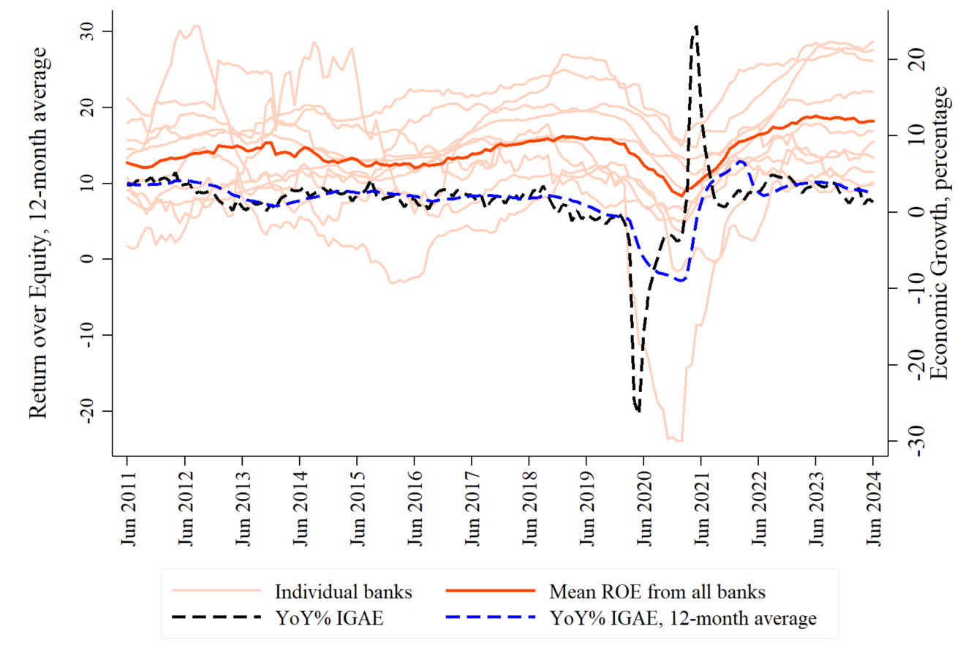

Figure shows the 12-month average of Return on Equity (ROE) from individual banks, and the mean from all banks of sample, compared to the economic activity growth from June 2011 to June 2024. Own elaboration with data from CNBV and INEGI.

The short-term interest rate is often used to capture monetary policy was the 28-day Mexican Federal Treasury Certificates (CETES), which closely reflect the stance of the central bank. Figure 4 shows the how CETES evolve over time, exhibiting a co-movement with bank profitability, as previous suggested in literature. Statistical data for IGAE and CPI are publicly released by the Instituto Nacional de Estadística y Geografía (INEGI), while CETES data is published by the Banxico.

**Figure 4. Short-term interest rate and ROE from all banks**

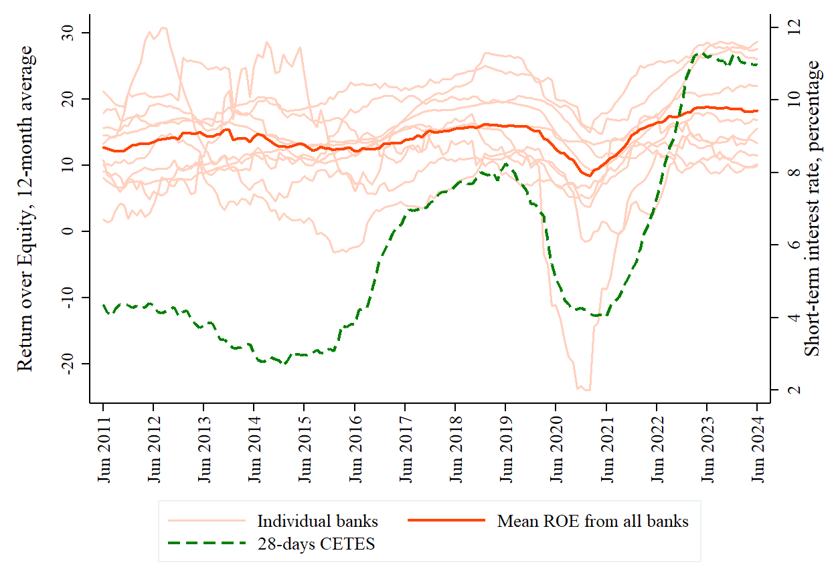

Figure shows the 12-month average of Return on Equity (ROE) from individual banks, and the mean from all banks of sample, compared to the rate of 28-day Mexican Federal Treasury Certificates (CETES) from June 2011 to June 2024. Own elaboration with data from CNBV and Banxico.

1. **Methodology**

In line with bank-profitability literature, we include in our models all variables that been shown to be relevant in empirical studies from other countries. For our model, we estimate a panel regression with cluster-robust standard errors, often used to accounts for autocorrelation and heteroskedasticity. Following Sajid Saeed (2014), the Hausmann Test is used to determine whether fixed-effects or random-effects are appropriate for the panel data model.

Our model includes variables that have been previously found significant in other countries. The equation to be estimated is as follows [2]:

We evaluate the robustness of our models by also estimating the models by using generalized least squares (GLS), which also accounts for autocorrelation and heteroskedasticity issues in the models. GLS has been found to be efficient, as it incorporates these issues directly (Bai et al., 2020).

1. **Results**

The first model includes all the variables mentioned before, as shown in Table 4. The Wooldridge test and the Modified Wald test for groupwise heteroskedasticity indicate that all models have both autocorrelation and heteroskedasticity issues.

|  |  |  |  |  |  |  |  |  |  |  |  |  |  |
| --- | --- | --- | --- | --- | --- | --- | --- | --- | --- | --- | --- | --- | --- |
| **Table 4. Panel estimation of bank performance (ROE), Jun 2011 to Jun 2024** | | | | | | | | | | | | |  |
|  |  | Panel regression with  cluster-robust standard errors | | | | |  | | GLS regression allowing for  heteroskedasticity across panels | | | | | | |  | |
|  |  | (1) | (2) | (3) | (4) | (5) | | (1) | | (2) | (3) | (4) | | | (5) | |
| LIQ |  | -0.331** | -0.296*** | -0.295*** | -0.328** | -0.283** | | -0.495*** | | -0.406*** | -0.406*** | -0.494*** | | | -0.424*** | |
|  |  | (0.139) | (0.11) | (0.11) | (0.142) | (0.099) | | (0.017) | | (0.016) | (0.016) | (0.017) | | | (0.023) | |
| CAR |  | 0.462** | 0.367** | 0.368** | 0.458* | 0.424** | | 0.580*** | | 0.492*** | 0.493*** | 0.591*** | | | 0.426*** | |
|  |  | (0.226) | (0.165) | (0.165) | (0.228) | (0.186) | | (0.046) | | (0.045) | (0.045) | (0.046) | | | (0.049) | |
| AM |  |  | 2.332*** | 2.328*** |  | 2.290** | |  | | 2.189*** | 2.187*** |  | | | 2.316*** | |
|  |  |  | (0.763) | (0.773) |  | (0.721) | |  | | (0.131) | (0.131) |  | | | (0.135) | |
| NIR |  |  |  |  | 0.000 | 0.00258** | |  | |  |  | -0.00558** | | | -0.00444* | |
|  |  |  |  |  | (0.001) | (0.001) | |  | |  |  | (0.003) | | | (0.002) | |
| UNCERTAIN |  |  |  | -0.002 |  | -0.002 | |  | |  | -0.001 |  | | | -0.002 | |
|  |  |  |  | (0.007) |  | (0.007) | |  | |  | (0.004) |  | | | (0.004) | |
| MOR |  |  |  |  |  | -0.031 | |  | |  |  |  | | | 0.025 | |
|  |  |  |  |  |  | (0.18) | |  | |  |  |  | | | (0.072) | |
| GROWTH |  | 0.412* | 0.335* | 0.331* | 0.412 | 0.201* | | 0.193*** | | 0.205*** | 0.201*** | 0.195*** | | | 0.227*** | |
|  |  | (0.244) | (0.174) | (0.184) | (0.245) | (0.108) | | (0.035) | | (0.034) | (0.036) | (0.035) | | | (0.037) | |
| INF |  | -0.305 | -0.331 | -0.331 | -0.304 | -0.182 | | -0.278*** | | -0.287*** | -0.287*** | -0.286*** | | | -0.291*** | |
|  |  | (0.24) | (0.23) | (0.23) | (0.24) | (0.16) | | (0.078) | | (0.075) | (0.075) | (0.078) | | | (0.077) | |
| INT |  | 0.674*** | 0.548** | 0.554** | 0.676** | 0.807*** | | 0.754*** | | 0.569*** | 0.574*** | 0.745*** | | | 0.534*** | |
|  |  | (0.226) | (0.217) | (0.221) | (0.228) | (0.212) | | (0.045) | | (0.044) | (0.047) | (0.045) | | | (0.049) | |
| Constant |  | 8.762*** | 8.179*** | 8.233*** | 8.750*** | 47.16 | | 9.114*** | | 7.809*** | 7.855*** | 9.171*** | | | 2.681* | |
|  |  | (3.131) | (2.627) | (2.677) | (2.592) | (34.79) | | (0.629) | | (0.627) | (0.642) | (0.631) | | | (1.387) | |
| Haussmann test |  | 0.6634 | 0.3781 | 0.3768 | 0.0327 | 0 | | 0.6634 | | 0.3781 | 0.3768 | 0.0327 | | | 0 | |
| Wooldridge test |  | 0.000 | 0.000 | 0.000 | 0 | 0 | | 0 | | 0.000 | 0.000 | 0 | | | 0 | |
| Modified Wald test |  | 0.000 | 0.000 | 0.000 | 0 | 0 | | 0 | | 0.000 | 0.000 | 0 | | | 0 | |
| Effects (R/F) |  | R | R | R | F | F | | - | | - | - | - | | | - | |
| Observations |  | 1570 | 1570 | 1570 | 1570 | 1570 | | 1570 | | 1570 | 1570 | 1570 | | | 1570 | |
| Number of banks |  | 10 | 10 | 10 | 10 | 10 | | 10 | | 10 | 10 | 10 | | | 10 | |
| R-squared |  | 0.3795 | 0.4972 | 0.4971 | 0.308 | 0.452 | | 0.6145 | | 0.7011 | 0.7011 | 0.6169 | | | 0.7055 | |

Robust standard errors in parentheses. Dependent variable is the average return over equity (ROE), calculated as the total net income accumulated over 12 months divided by average equity over 12 months. Columns one to five were estimated using a panel regression with cluster-robust standard errors. Columns six to ten were estimated using generalized least squares (GLS) regression allowing for heteroskedasticity across panels. Diagnostics section include p-values of tests. Overall $R^{2}$ is reported for panel regression, while Pseudo- $R^{2}$ is reported for GLS. Asterisks denote significance at the 10% (*), 5% (**), and 1% (***) levels.

The coefficient $β_{1}$ remains consistently positive in all regressions, suggesting that the economic growth trend does exert a meaningful effect on bank profitability across all models as previously expected.

The coefficient $β_{2}$ shows that inflation is negative related to profitability, in line with previous studies, but results were statistically insignificant. Results of both variables are equally not significant when using GLS, which confirms that inflation does not contribute to our model.

Short term interest rates are shown to having an impactful and significant effect on profitability. Regression 3 suggest that a percentage increase in interest rates,

# Robustecer el modelo y conclusiomes

# Tabla 2, checar si los coefficients que salieron significativos siguen con s mismo signo y significancia quitando controles, y con algunos contrles y otros

# Tabla 3.

Results suggest that an 1 porcentage increase in short term interest rates increase profitability to a .078 porcentage points increase in ROE.

Morales Castro & Espinosa Jiménez (2024) explain that reduction on profitability was due to a contraction in economic growth. However, our results yield different results. When using an extended by data period, significance in economic growth fades in favor of interest rate

conclude that economic growth was not the driving affecting profitability but rather the subsequent decline in interest rates

**Table 5. Profitability and bank-specific variables**

Robust standard errors in parentheses. Dependent variable is the average return over equity (ROE), calculated as the total net income accumulated over 12 months divided by average equity over 12 months. Columns one to three were estimated using a panel regression with cluster-robust standard errors. Columns four to six were estimated using generalized least squares (GLS) regression allowing for heteroskedasticity across panels. Diagnostics section include p-values of tests. Asterisks denote significance at the 10% (*), 5% (**), and 1% (***) levels.

Robustness

1. **Conclusions**

This paper presents empirical

Ddddd

Propose policy actions that should be taken to improve bank profitability

Further research can be conducted by investigating the effects of other type of news on the outlook of bank profitabulty

How uncertainty derived from economic policy may affect smaller banks

Alternative measurements of bank profitability

All panel regression were estimated using random effects as there are no unobservable bank-specific effects, given that macroeconomic variables influence the whole banking system.

References

Adelopo, I., Vichou, N., & Cheung, K. Y. (2021). Capital, liquidity, and profitability in European banks. *Journal of Corporate Accounting &Amp; Finance, 33*(1)10.1002/jcaf.22522

Albertazzi, U., & Gambacorta, L. (2009). Bank profitability and the business cycle. *Journal of Financial Stability, 5*(4), 393–409. 10.1016/j.jfs.2008.10.002

Alcaraz, C., Amoroso, N., Oviedo, R., Rivadeneira, A., Samaniego, B., & Sapriza, H. (2024). The Real Effects of Credit Supply Shocks During the COVID-19 Pandemic. *Working Papers, 2024-16* <https://www.banxico.org.mx/publications-and-press/banco-de-mexico-working-papers/%7BDFA9FE50-8521-0964-9F46-E8C67EEDE6C7%7D.pdf>

Al-Homaidi, E., Tabash, M. I., Farhan, N. H. S., & Almaqtari, F. A. (2018). Bank-specific and macro-economic determinants of profitability of Indian commercial banks: A panel data approach. *Cogent Economics & Finance, 6*(1), 1548072. 10.1080/23322039.2018.1548072

Athari, S. A., & Bahreini, M. (2023). The impact of external governance and regulatory settings on the profitability of Islamic banks: Evidence from Arab markets. *International Journal of Finance & Economics, 28*(2), 2124–2147. 10.1002/ijfe.2529

Ayaydin, H., & Karakaya, A. (2014). The Effect of Bank Capital on Profitability and Risk in Turkish Banking. *International Journal of Business and Social Science, 5*, 252–271.

Bai, J., Choi, S. H., & Liao, Y. (2020). Feasible Generalized Least Squares for Panel Data with Cross-sectional and Serial Correlations.*60*, 309–326. /10.1007/s00181-020-01977-2

Baker, S. R., Bloom, N., & Davis, S. J. (2016). Measuring Economic Policy Uncertainty. *The Quarterly Journal of Economics, 131*(4), 1593–1636. /10.1093/qje/qjw024

Bikker, J. A., & Vervliet, T. M. (2018). Bank profitability and risk-taking under low interest rates. *International Journal of Finance & Economics, 23*(1), 3–18. 10.1002/ijfe.1595

Bush, G., & López Noria, G. (2021). Uncertainty and exchange rate volatility: Evidence from Mexico. *International Review of Economics & Finance, 75*, 704–722. 10.1016/j.iref.2021.04.029

Chaudron, R. (2018). Bank's interest rate risk and profitability in a prolonged environment of low interest rates. *Journal of Banking & Finance, 89*, 94–104. 10.1016/j.jbankfin.2018.01.007

Chavarín, R. (2014). Determinants of Commercial Bank Profitability in Mexico. *EconoQuantum, 12*(1), 97–123. /10.18381/eq.v12i1.4855

Chavarín-Rodríguez, R. (2015). Morosidad en el pago de créditos y rentabilidad de la banca comercial en México.*1*, 73–85. <http://www.scielo.org.mx/scielo.php?script=sci_arttext&pid=S1665-53462015000100073&lng=es&tlng=es>

Chi, Q., & Li, W. (2017). Economic policy uncertainty, credit risks and banks’ lending decisions: Evidence from Chinese commercial banks. *China Journal of Accounting Research, 10*(1), 33–50. 10.1016/j.cjar.2016.12.001

Chiguil-Rojas, A., Esquivel, G., & Leal, J. (2024). *La transmisión de la política monetaria a través del crédito bancario en México*. Fondo de Cultura Economica. 10.20430/ete.v91i363.2230

Chortareas, G. E., Garza-Garcia, J. G., & Girardone, C. (2009). Market structure, profits, and spreads in the Mexican banking industry.*4*(3), 43–52. <https://repository.essex.ac.uk/7210/>

CNBV. (2025). *Disposiciones De Carácter General Aplicables A Las Instituciones De Crédito*. Diario Oficial de la Federación.

Converse, N., & Jain, A. K. (2024). *Do Banks Gain from Inflation? Evidence from Inflation Surprises*. Federal Reserve Board of Governors.

Economic Policy Uncertainty. (2012). *Mexico Monthly Index.* <https://www.policyuncertainty.com/mexico_monthly.html>

Elekdag, S., Malik, S., & Mitra, S. (2020). Breaking the Bank? A Probabilistic Assessment of Euro Area Bank Profitability. *Journal of Banking & Finance, 120*, 105949. 10.1016/j.jbankfin.2020.105949

Guerrero, R., & Villalpando, M. (2009). Rentabilidad, concentración y eficiencia en el sistema bancario mexicano. *Trimestre Economico, 76*(1), 237–263.

Guerrero-Mora, R., & Villalpando-Benítez, M. (2009). Rentabilidad, concentración y eficiencia en el sistema. *El Trimestre Económico, 76*(301), 237–263. <https://doi.org/10.20430/ete.v76i301.481>

Hancock, D. (1985). Bank profitability, interest rates, and monetary policy. *Journal of Money, Credit and Banking, 17*(2), 189–202. 10.2307/1992333

Jokipii, T., & Milne, A. (2011). Bank capital buffer and risk adjustment decisions. *Journal of Financial Stability, 7*(3), 165–178. 10.1016/j.jfs.2010.02.002

Magallón González, H. B., Galeana Figueroa, E., & De La Torre-Torres, O. V. (2023). The effect of banking channels and efficiency indicators on bank profitability. *Mercados Y Negocios, 24*(48)10.32870/myn.vi48.7685

Martínez-Vázquez, D., Martínez-Preece, M., & Reyes-Zárate, F. (2025). Efecto macroeconómico en la morosidad de créditos al consumo y su impacto en la rentabilidad bancaria en México. *Revista Mexicana De Economía Y Finanzas Nueva Época REMEF, 20*(2)10.21919/remef.v20i2.876

Mashamba, T. (2018). The Effects of Basel III Liquidity Regulations on Banks’ Profitability. *Journal of Governance and Regulation, 7*(2), 34–48. 10.22495/jgr_v7_i2_p4

Molyneux, P., Remolona, E., & Seth, R. (1998). Modeling Foreign Bank Performance and Lending Behavior. *Financial Markets, Institutions & Instruments, 7*(4), 26–41. 10.1111/1468-0416.00022

Morales Castro, J. A., & Espinosa Jiménez, P. M. (2024). Economic variables and bank profitability in Mexico: period before and during COVID-19. *Análisis Económico, 39*(100), 99–118. 10.24275/uam/azc/dcsh/ae/2024v39n100/morales

Nasim, A., Downing, G., & Nasir, M. A. (2025). The Role of Uncertainty, Regulatory and Economic Environment and Quantitative Tightening in Banks’ Performance. *International Journal of Finance & Economics, n/a*10.1002/ijfe.3128

Orden-Cruz, C., Paule-Vianez, J., & Lobão, J. (2023). The effect of Economic Policy Uncertainty on the credit risk of US commercial banks. *International Journal of Finance & Economics, 28*(3), 3420–3436. 10.1002/ijfe.2600

Ozili, P. K. (2017). Bank Profitability and Capital Regulation: Evidence from Listed and non-Listed Banks in Africa. *Journal of African Business, 18*(2), 143–168. 10.1080/15228916.2017.1247329

Pradhan, R. S., & Shrestha, D. (2017). *Impact of Liiquidity on Bank Pofitability in Nepalese Commercial Banks*/10.2139/ssrn.3044041

Sajid Saeed, M. (2014). Bank-related, Industry-related and Macroeconomic Factors Affecting Bank Profitability: A Case of the United Kingdom. *Research Journal of Finance and Accounting Www.Iiste.Org, 5*(2)

Samuelson, P. A. (1945). The Effect of Interest Rate Increases on the Banking System. *The American Economic Review, 35*(1), 16–27. <http://www.jstor.org/stable/1810106>

Sosa Castro, M. M., Ortiz, E., & Cabello-Rosales, A. (2022). Impacto de la incertidumbre de la política económica en la actividad económica y mercado bursátil y cambiario mexicanos: un modelo DCC. *Lecturas De Economía,* (98), 29–55. 10.17533/udea.le.n98a349886

Wu, J., Yao, Y., Chen, M., & Jeon, B. N. (2020). Economic uncertainty and bank risk: Evidence from emerging economies. *Journal of International Financial Markets, Institutions and Money, 68*, 101242. 10.1016/j.intfin.2020.101242

# Finally, recent interest on financial inclusion has sparked a new line of research examining the impact of accessibility and financial services on bank performance. A recent contribution by Magallón González et al. (2023) included financial innovation indicators, such as automatic teller machines (ATMs). However, results had weak influence on overall profits.

As with ATM, transaction on mobile may help banks keep concentration on their banking system share and not increment their profitability directly

Labour productivity = Gross revenue/number of employees

Use of net capital over risk weighted assets, as using standard capital over total assets

In order as tier ii capitalization reflects true risk and potential losses of riskier positions.

Tier ii capitalization discourages capital arbitrages, that is having a high-risk asset portafolio over the required minimun capitalization

1. General Provisions Applicable to Credit Institutions, Articule 110, Bis define Stage 3 Credit Risk as loans considered impaired, with significant credit deterioration or 90 days or more past due (CNBV, 2025).
2. The equation represents the specification of the regression model using random effects.